Easy Read

Arts Council of Wales
How did you find applying for our funding during coronavirus?
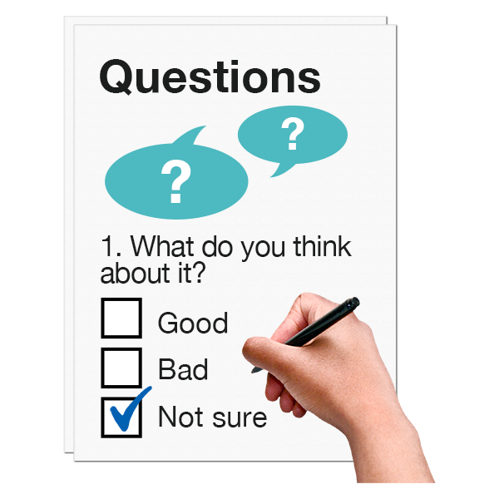

This document was written by the Arts Council of Wales. It is an easy read version of “COVID 19 Application Evaluation”.
July 2020

 | Introduction
 | We are Arts Council of Wales. Earlier this year we quickly set up funding to support arts organisations and people during coronavirus.
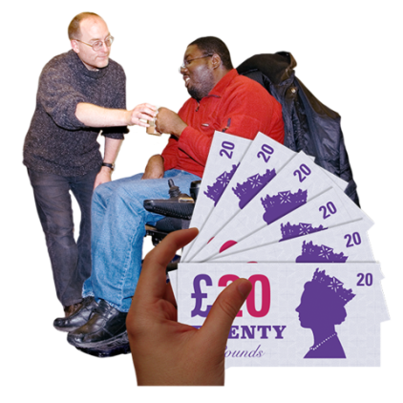 | Funding is money people or organisations can get to help them do their work. They do not have to pay it back.
 | We want to check if there is anything we could have done better. We want to make sure we are giving the best information and support.
If you applied for this funding please help us by answering these questions. We would like to hear from:
- people who got the money they asked for
- and people who did not get money.
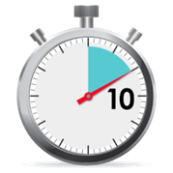 | It should take about 10 minutes to answer these questions
 | We will not give any information to others that tells who you are. For example your name, phone number.
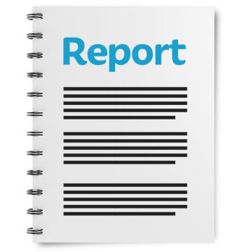 | We may put some answers on our website. Or in reports we write.
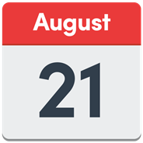 | Please send us your answers by 21 August 2020.
Please e-mail your answers to:
Email: research@arts.wales
If you have any questions you can e-mail us or call:
Phone: 029 2044 1375

 | This document was made into easy read by Easy Read Wales using Photosymbols.

Questions

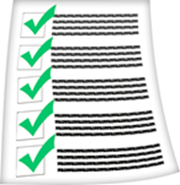 | Which fund did you apply for?  You can tick more than 1 box.
 | Urgent Response Fund for Individuals | ☐
 | Organisations Stabilisation Fund | ☐
 | Individuals Stabilisation Fund | ☐

 | Did you get money?
 | Yes | ☐
 | No | ☐

 | What application form did you fill in?
 | Main version | ☐
 | Easy read version | ☐

How did you find out about our funding?
You can tick more than 1 box.
 | Arts Council of Wales website | ☐
 | Arts Council of Wales newsletter | ☐
 | Arts Council of Wales Twitter | ☐
 | Somewhere else. Please say where in the box below. | ☐

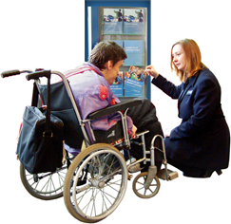 |  | Are there other places where you think we should put up information about our funding?

If you contacted us before you applied were you happy with how we dealt with you?
Very happy | Happy | Unhappy | Very unhappy | I did not contact you
☐ | ☐ | ☐ | ☐ | ☐

How easy was it to find information about funding on our website?
Very easy | Easy | Hard | Very hard
☐ | ☐ | ☐ | ☐

How easy was it to fill out the application form?
Very Easy | Easy | Hard | Very hard
☐ | ☐ | ☐ | ☐

How quickly did you get a decision about your application?
Very quick | Quick | Slow | Very slow
☐ | ☐ | ☐ | ☐

If you spoke to us after you got your decision, how happy are you with the way we dealt with you?
Very Happy | Happy | Unhappy | Very unhappy | I did not speak to anyone
☐ | ☐ | ☐ | ☐ | ☐

What about the funding do you think worked well?
What about the funding did not work well?

What do you think we need to change if we have this funding again?

 | 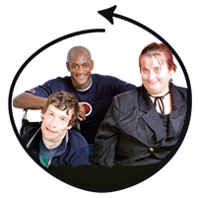 | How can we make sure everyone feels that they can apply for funding?

After lockdown is over:
What do you think is the most important thing we should be doing? How could we do this?

 | What happens next
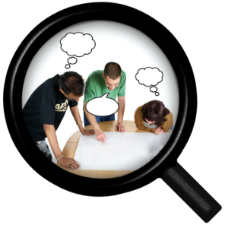 | We may ask people to take part in a group to help us look at how we can make things right.
 | If you would like to take part in a group please tell us your name and email address.

Your full name:

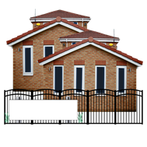 | Your organisation:  (If you have one)

Your email address:

Thank you!

